RTX Corporation (NYSE: RTX) Full Analysis
Upgraded visual report with market snapshot, Q1 earnings, guidance, segments, analyst context, and historical trend panels. Data cleaned for percentage-format consistency.

1. Executive Summary
- RTX closed at $174.26 on 2026-04-24, with the stock still below the 20-day, 50-day, and 200-day moving averages.
- Analyst consensus is still constructive, with a mean target of $215.06, 22 analysts, and an average rating of 2.1 - Buy.
- Q1 2026 reporting was operationally solid, with revenue, adjusted EPS, free cash flow, and backlog metrics supporting the argument that RTX remains a real institutional-quality business.
- Management raised 2026 sales guidance and the EPS range while reaffirming free-cash-flow guidance, which is fundamentally supportive.
- The problem remains technical. A good quarter and decent guidance do not automatically make a broken or weak chart deployable.
- Data-quality note: company-market fields and analyst metrics were pulled live, while the earnings, guidance, and segment visual blocks were intentionally curated from the reported quarter so the report reads cleanly instead of depending on fragile web extraction.

2. Visual Snapshot
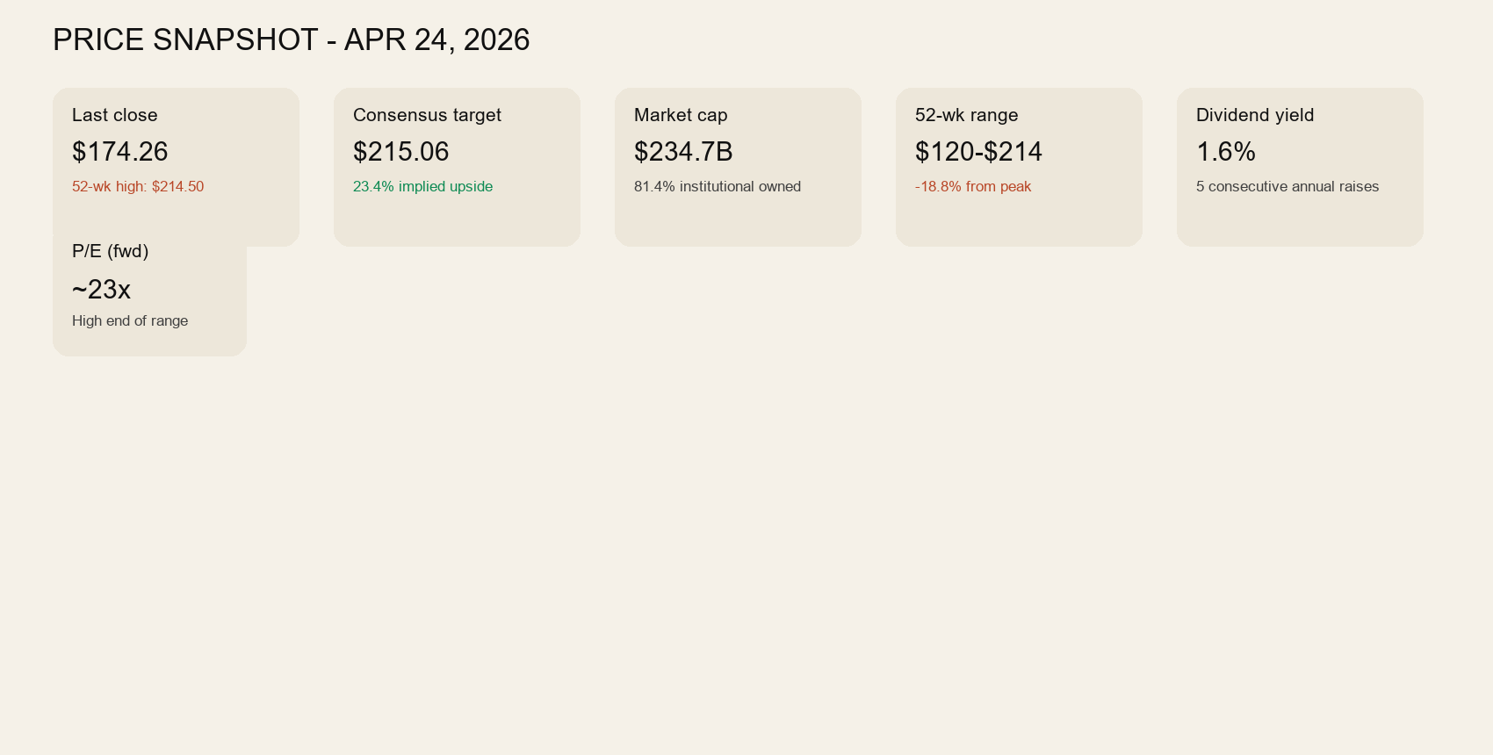
This panel shows the current price context, consensus target, market value, 52-week range, dividend profile, and forward multiple at a glance.

3. Q1 2026 Results and Guidance
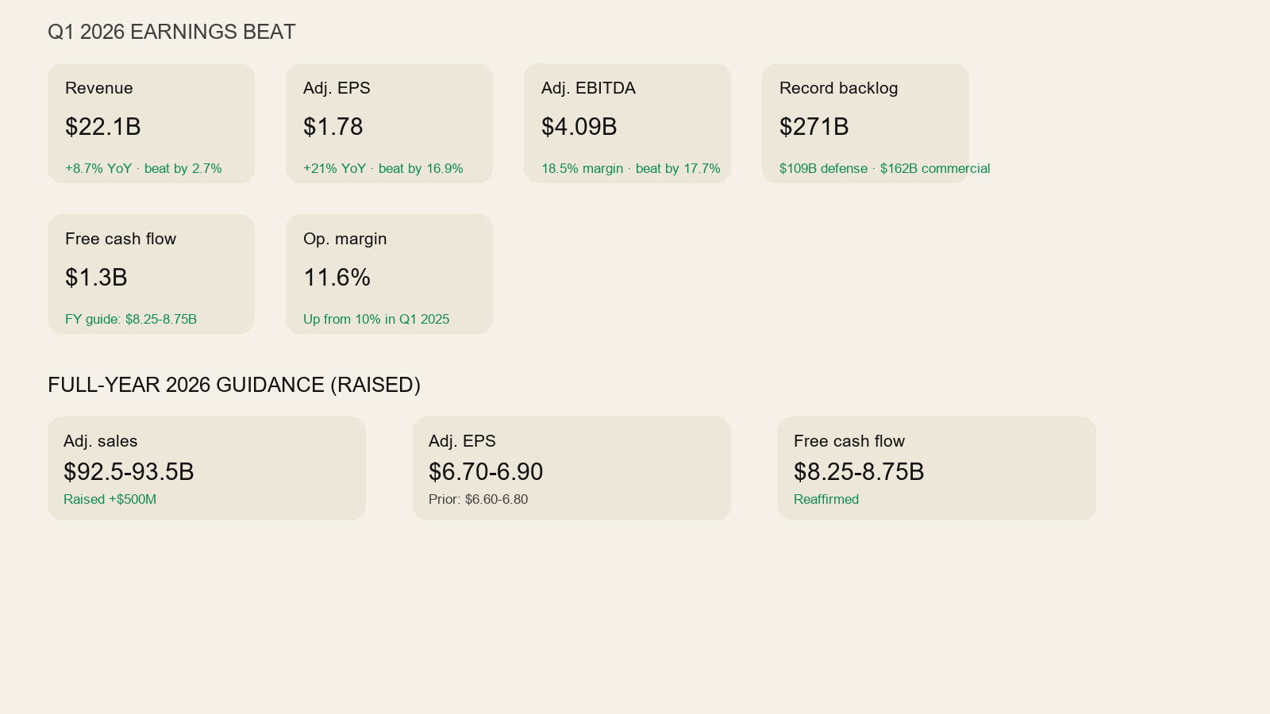
This panel captures the quarter's headline results and the updated full-year 2026 guidance frame. The quarter was fundamentally supportive, even if the stock's post-earnings chart has not yet confirmed that support.

4. Segment Performance
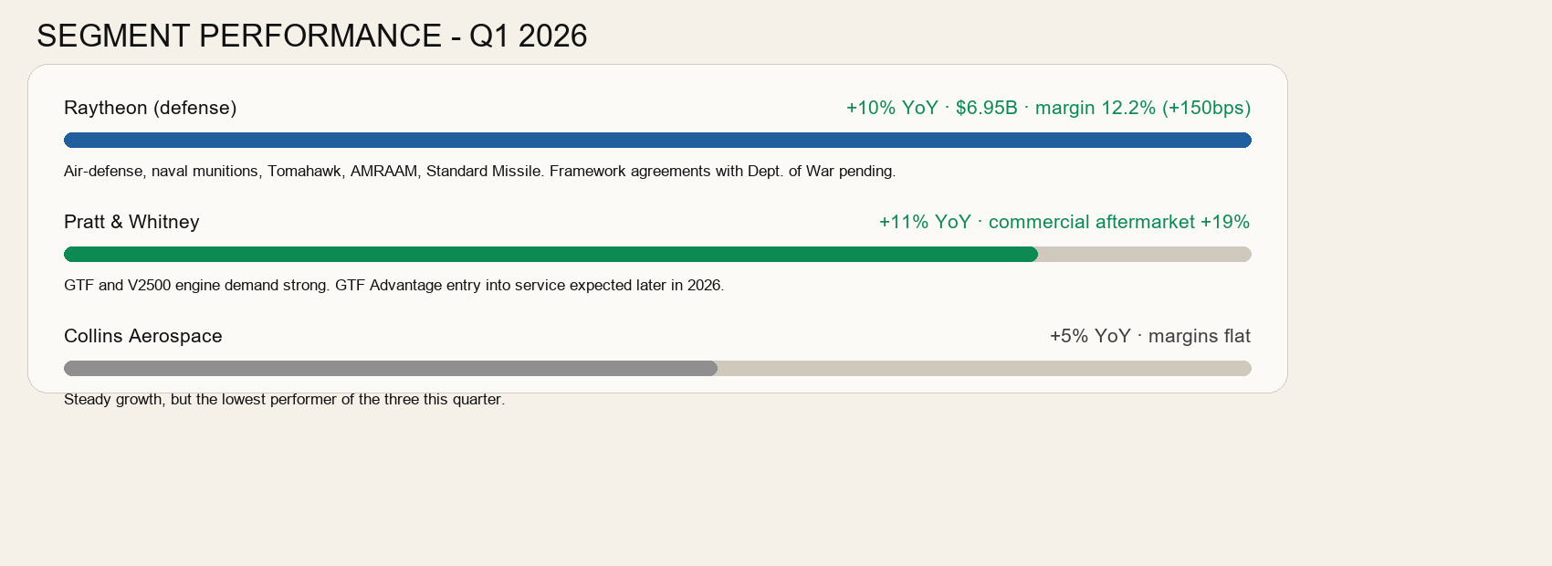
- Raytheon led with the strongest defense read-through, supported by missile and air-defense demand.
- Pratt & Whitney also contributed strong growth, with commercial aftermarket strength doing real work.
- Collins Aerospace remained positive, but it was the softest of the three major segments in this quarter's framing.

5. Historical EPS and Revenue Trend
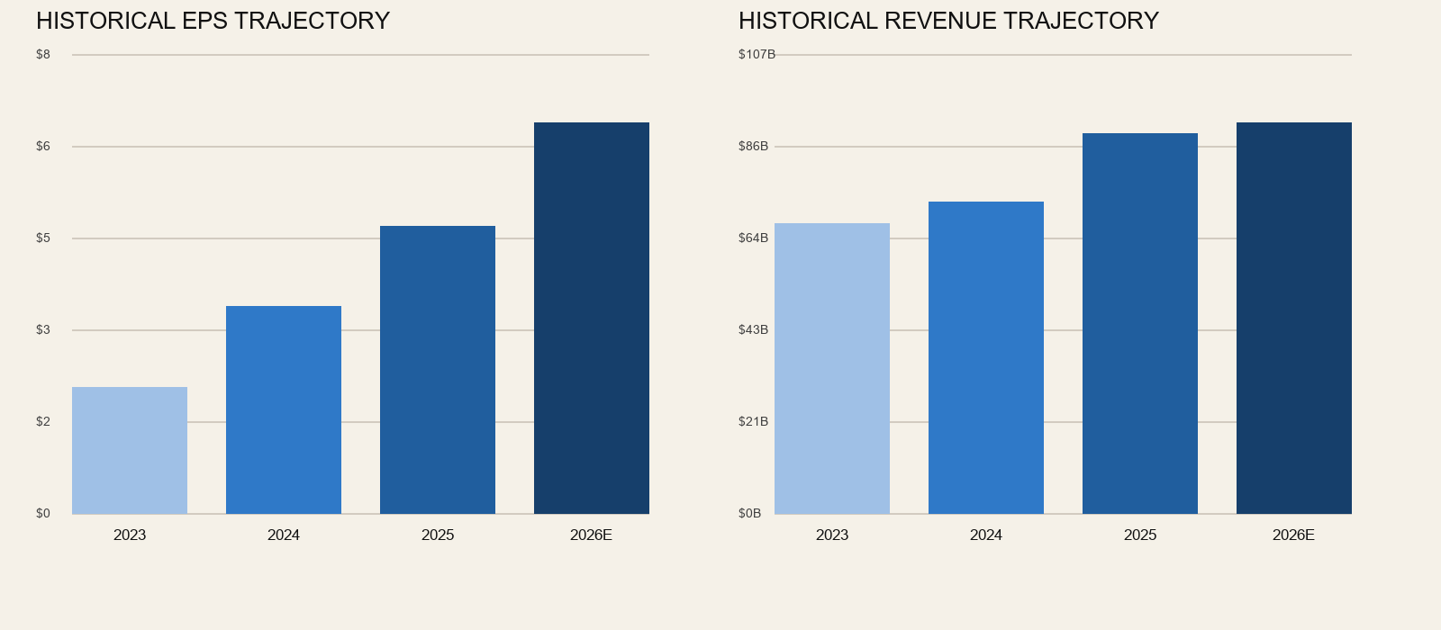
The trend panel reinforces the core fundamental point: RTX is not a low-quality story stock. The business has shown meaningful earnings and revenue progression, with 2026 expectations still moving higher.

6. Analyst Setup
Metric | Value
Current price | $174.26
Consensus target | $215.06
Median target | $222.50
Target range | $179.00 to $242.00
Average analyst rating | 2.1 - Buy
Recommendation | Buy
Analyst count | 22
- Consensus is still broadly constructive, which means the market has not abandoned the long-term business case.
- That does not override the current chart. Analyst upside is useful context, not an entry trigger.
- If price continues to deteriorate, target-based upside can stay theoretical for a long time.

7. Financial Quality and Valuation
Metric | Value
Market cap | $234.7B
Enterprise value | $268.5B
Total revenue | $90.4B
Free cash flow | $7.2B
Operating cash flow | $11.1B
Total debt | $38.9B
Total cash | $6.8B
Trailing P/E | 32.7
Forward P/E | 23.1
Price / Sales | 2.60
Price / Book | 3.59
Dividend yield | 1.6%
Profit margin | 8.0%
Operating margin | 13.2%
Gross margin | 20.2%
ROE | 11.6%
ROA | 4.1%
Revenue growth | 8.7%
Earnings growth | 32.5%
Current ratio | 1.02
Quick ratio | 0.65
Debt / equity | 57.2

8. Technical Verdict
- RTX is below the 20-day ($193.88), 50-day ($199.09), and 200-day ($178.08) moving averages.
- Recent support is near $174.26. Recent resistance is near $203.48.
- That posture is weak. It does not support a fresh aggressive long entry today.
- The right upgrade path is a repair sequence: stabilize, reclaim the 20-day, then reclaim the 50-day with a defined entry band and invalidation.
- Until that happens, RTX remains a bench name, not an active deployment candidate.

9. Bottom Line
RTX now has a better report. Fundamentally, it looks like what it is: a large, real aerospace and defense franchise with solid quarterly execution, improved full-year guidance, strong backlog, and continuing analyst support. But the stock still does not look ready. The technical picture remains weak enough that the correct call is still patience. In this framework, RTX belongs on the tactical aerospace and defense bench until price structure improves. The report supports keeping it in coverage. It does not support forcing capital into it today.

